Contents

Philips Blog 1

Six ways healthcare will move into our homes 1

FDA认证 7

公司：MaxQ AI 平台：Accipio Insight 7

数坤冠脉AI产品 7

西门子医疗提出智慧诊断链条： 8

竞赛 9

Modality Imaging 10

CT扫描和读片 10

Implementation Tools 11

Organs 11

# Philips Blog

## Six ways healthcare will move into our homes

“The hospital room of the future will be the bedroom,” cardiologist Eric Topol wrote in 2015, foretelling a world in which monitoring of vital signs and other relevant physiological metrics would shift from the hospital to the home for all but the most acutely ill patients [1].

Five years later, this prediction seems ever more prescient – in ways that few of us could have imagined just a few months ago.

In the face of COVID-19, many healthcare providers turned to remote patient monitoring and virtual visits to continue caring for vulnerable patients while minimizing risk of virus transmission and reducing the strain on scarce hospital resources. It has given a new and urgent impetus to implement digital health solutions at scale, with telehealth projected to grow by 64% in the U.S. this year alone.

Sooner or later, the threat from COVID-19 will go away. But the need to rethink where and how we deliver healthcare won’t.

What the pandemic is bringing to the fore is how our homes are destined to play a central role in the healthcare system of the future. Rather than having patients travel to see healthcare providers, can we bring healthcare to their doorsteps?

Rather than having patients travel to see healthcare providers, can we bring healthcare to their doorsteps?

It’s a shift that many people would welcome. Consumer interest in remote and virtual health services is seeing an uplift following COVID-19, accentuating the need for increased access and convenience of care. With banking, retail, and other industries already offering 24/7 digital access to their services for many years, healthcare will have to follow suit to meet the expectations of today’s consumer.

There is an urgent economic need for change, too. The reality is that today’s hospital-centric model of care is financially unsustainable as demand for healthcare services continues to grow around the world. To keep healthcare affordable, it will need to move into lower-cost settings such as the home whenever possible.

But this is not just about moving care delivery out of the hospital. It’s about acknowledging that our health is largely shaped by what takes place before and after doctor or hospital visits. Remote digital health technology can foster a more holistic, longitudinal, and ultimately effective approach to taking care of health and health issues. An approach in which ongoing management of chronic conditions and preventative health strategies are as much a priority as providing care to the critically ill.

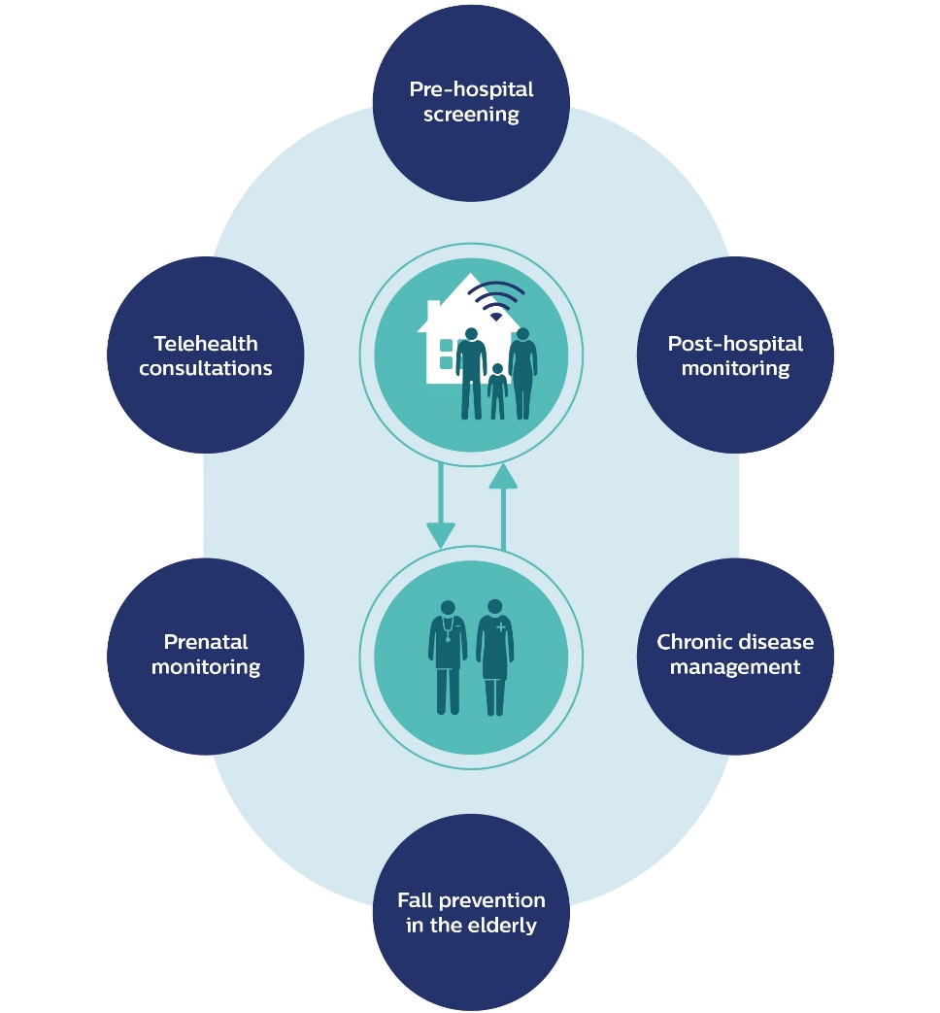

I see six areas in which this vision is already coming into fruition. Let’s explore each of them in more detail.

1. Screening and supporting patients remotely before they enter the hospital

During the COVID-19 crisis, we have seen how remote screening and monitoring of suspected Coronavirus patients can help to safeguard critical care capacity and prevent unnecessary visits to general practitioners and hospitals.

Here’s how it works: Patients first complete an online questionnaire at home. Based on the results, the caregiver can assign patients to a risk class and take appropriate actions. If needed, patients can be monitored via automated follow-up surveys. Patients with a high-risk score are contacted by a call center for additional information before referring them to their general practitioner, who can then provide the necessary care or direct them to the hospital.

Developed in collaboration with Dutch care providers, this remote screening solution has been used by hospitals and home care organizations to keep patients and staff safe. As a next step, patients could also receive wearable health monitoring devices to remotely track potential deterioration.

In a similar vein, forward-thinking hospitals are exploring other types of remote patient engagement prior to medical intervention – connecting with patients at home as they prepare for a procedure. For example, pre-surgery health coaching could help to get patients in optimal condition before they have elective surgery, in order to shorten hospital length of stay and prevent avoidable readmissions. The underlying vision is as simple as it is powerful: “Better in, better out.”

2. Keeping a caring eye on patients following hospital discharge

Remote health monitoring in the home can be equally valuable after patients have received care in a hospital. Following hospital discharge, patients are typically disconnected from healthcare oversight – contributing to potentially avoidable hospital readmissions that cause patient distress and cost more than $17 billion in the U.S. alone [2].

Increasingly, we will see the use of remote patient monitoring, for example using wearable sensors to keep watch of patients after hospital discharge. These sensors, which are already in use in lower-acuity hospital settings today, can collect and transmit critical data such as heart rate, respiratory rate, skin temperature, and body posture.

In addition, people will be able to provide regular feedback on their health and quality of life by filling out online questionnaires or talking to a chat bot – without having to leave the house. I have written before about the value of tracking such patient-reported outcomes in home monitoring of prostate cancer. In the wake of COVID-19, it is also proving useful in monitoring Coronavirus patients following hospital discharge.

Bringing various health measures and patient-reported outcomes together allows healthcare providers to detect early signs of deterioration and to invite patients to the hospital for follow-up treatment when needed.

3. Empowering patients with chronic disease to manage their illness

Another group set to benefit from at-home medical technology is people with chronic diseases. About one in three people worldwide suffers from multiple chronic conditions, such as diabetes, hypertension, heart failure, or COPD [3]. Not only can these diseases severely impair quality of life for those affected, they put a heavy burden on our health systems too. In the U.S., it has been estimated that chronic diseases account for a staggering 75% of the nation’s total healthcare expenditure [4].

Home-based medical technology can help curtail those costs and improve quality of life – by tracking relevant health data, integrating them with other data sources such as electronic medical records, and translating the combined data into actionable insights. This can encourage patients to take an active role in managing their disease, while enabling care professionals to support them in a more targeted way. For example, at Philips we developed a cloud-based platform that allows homecare providers and physicians to remotely monitor patients with chronic sleep apnea, and to prioritize those in need of intervention or a change in care.

Connected home devices and home care management plans can also help address one of the most frequent problems that undermines the effectiveness of chronic care: lack of treatment adherence. According to the WHO, 50% of patients who suffer from chronic disease do not adequately adhere to their treatment recommendations [5]. Smart pill dispensers can be part of the solution by notifying patients to take pre-packaged unit doses of medication. Through an assist app that comes with the pill dispenser, family and caregivers are notified, enabling them to contact the patient when he or she does not take medication – supporting adherence to the therapy plan.

4. Enabling senior people to live independently

Elderly care at home is evolving just as rapidly thanks to remote technology. Falls are a leading cause of fatal and nonfatal injuries for people over 65. In the U.S., every 11 seconds an older adult is treated in the emergency room for a fall, and every 19 minutes, an older adult dies from the consequences of a fall [6]. What if we could identify those at risk of falling before a person actually suffers an injury?

Predictive analytics, using data collected via connected health technology, helps care providers do just that. It can combine data from multiple sources – including hospital-based electronic medical records, historical use of medical alert services, and auto-alerts that signaled previous falls – to identify seniors who are at risk of emergency transport in the next 30 days. This allows healthcare providers to reach out to a senior person proactively before a fall occurs, preventing unnecessary treatment in the hospital and driving down costs of transportation, acute care, and rehabilitation.

In the future, such services may be complemented by other types of monitoring that could eventually become embedded into the home itself. Researchers are exploring the possibility of mounting video or motion sensors in different locations of a smart home, specifically designed to support independent living by frail seniors [7]. These ambient sensors could work in conjunction with, or as an even less obtrusive replacement of wearable sensors or devices.

5. Providing remote prenatal care to expecting mothers

Pregnant women with specific health needs or risks are another group who may benefit from remote monitoring by healthcare professionals.

For example, Philips is partnering with Babyscripts to enable maternity clinics and hospitals to remotely monitor their pregnant patients’ blood pressure, weight, and other vital signs. This allows pregnant women and care providers to manage pregnancy-associated risks in between regular antenatal care visits by alerting them to changes in a woman’s health condition. Bringing professionally supervised ultrasound monitoring into the home could be a next step.

COVID-19 has further highlighted the value of remote prenatal care. It has been estimated that up to half a million women may deliver their babies in 2020 while infected with COVID-19. In fact, of those women who delivered in New York State between March 22 and April 4, 2020, 15% had COVID-19 [8]. Moreover, pregnant women who have not been diagnosed with COVID-19 are interested in ways they can minimize their time in a hospital to limit their exposure to the disease.

Responding to those needs, we recently announced the introduction of a wireless and disposable electrode patch that can be placed on the mother’s abdomen. The patch enables continuous, non-invasive monitoring of maternal heart rate, fetal heart rate, and uterine activity, for up to 48 hours. It only needs to be placed once instead of being repositioned every hour, limiting the amount of required physical interactions between nurses and patients – while helping them to stay connected remotely.

6. Improving access and convenience of health services for all

Although smart connected technology can support groups with special medical needs, the ultimate aim should be to support the health and well-being of all.

Technology that tracks health and lifestyle data, such as weight, blood pressure, or oral hygiene, can be further embedded into the home environment, for example via a smart mirror in the bathroom or mobile interfaces that display insights to support healthy living. Professional support will be at people’s fingertips, with telehealth services embedded into digital health applications that they can access from the comfort of their home.

In oral healthcare, for example, tele-dentistry allows people to consult dentists remotely by sharing images of their teeth via their smartphone – which opens the door to remote screening, diagnosis, consultation, treatment planning, and monitoring of disease progression. This holds particular promise for people who live in rural or isolated locations, where the nearest dentist may be many miles away.

COVID-19 has drastically accelerated adoption of tele-dentistry in the U.S., with many dental professionals switching to remote consultations to stay in touch with patients. Significantly, dental care providers can now submit claims and be reimbursed for patient consultations by telephone or livestreaming video. It may very well prove to be a tipping point for tele-dentistry – and it’s not hard to see how the pandemic could provide a boon to other forms of remote health consultation as well.

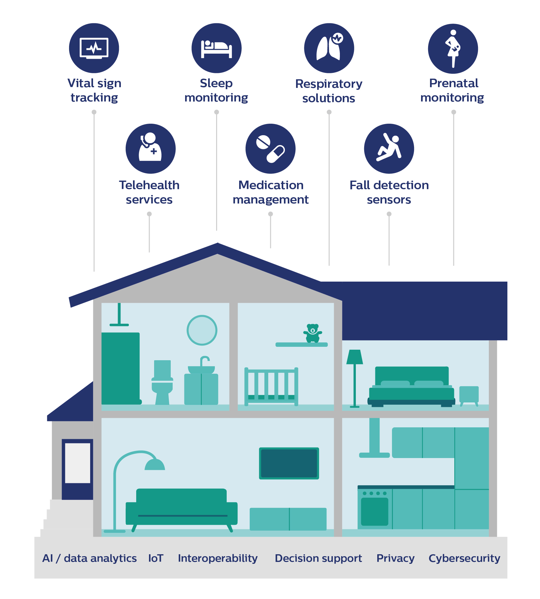

Staying in touch when it matters

Ultimately, the home as a place of care will be one in which IoT-enabled devices and sensors, combined with artificial intelligence and voice or video interfaces, are integrated seamlessly and unobtrusively to support people’s health and well-being. All linked to interoperable digital platforms that connect patients, care providers, and payers. With strict privacy and security controls in place.

It will help to connect the dots across people’s health journey, supporting value-based care that is focused on long-term health outcomes rather than on acute episodes of care.

At many moments along that journey, in-person care will remain indispensable – whether it is in the form of a visit from a caregiver, or a trip to the hospital or doctor’s office. But it will be reassuring to know that at the end of the day, when we retreat into our private little worlds, professional caregivers may never be far away – guarding or supporting us if and when we need them, even in the comfort of our homes.

References

[1] Topol, E. The patient will see you now: the future of medicine is in your hands. 2015.

[2] https://www.ncbi.nlm.nih.gov/pmc/articles/PMC6669363/

[3] https://www.ncbi.nlm.nih.gov/pmc/articles/PMC6214883/

[4] https://www.chronicdisease.org/page/whyweneedph2imphc

[5] https://www.who.int/chp/knowledge/publications/adherence_report/en/

[6] https://www.ncoa.org/news/resources-for-reporters/get-the-facts/falls-prevention-facts/

[7] https://www.ncbi.nlm.nih.gov/pmc/articles/PMC6068532/

[8] <https://www.nejm.org/doi/full/10.1056/NEJMc2009316>

# FDA认证

[2019nature]The practical implementation of artificial intelligence technologies in medicine

[2019nature]High-performance medicine: the convergence of human and artificial intelligence

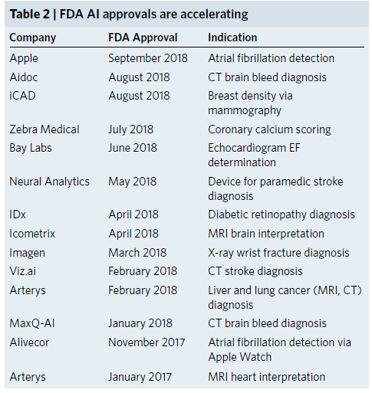

ClearView cCAD (describe lesion with BI-RADS in breast ultrasound image)

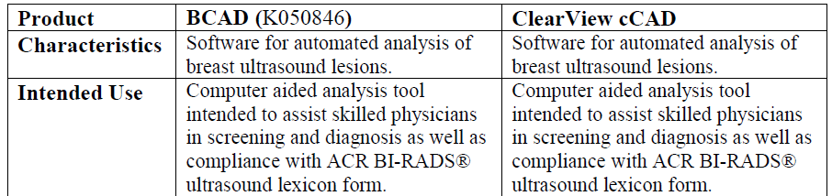

Koios CS for Breast (classify breast lesion in breast ultrasound image)

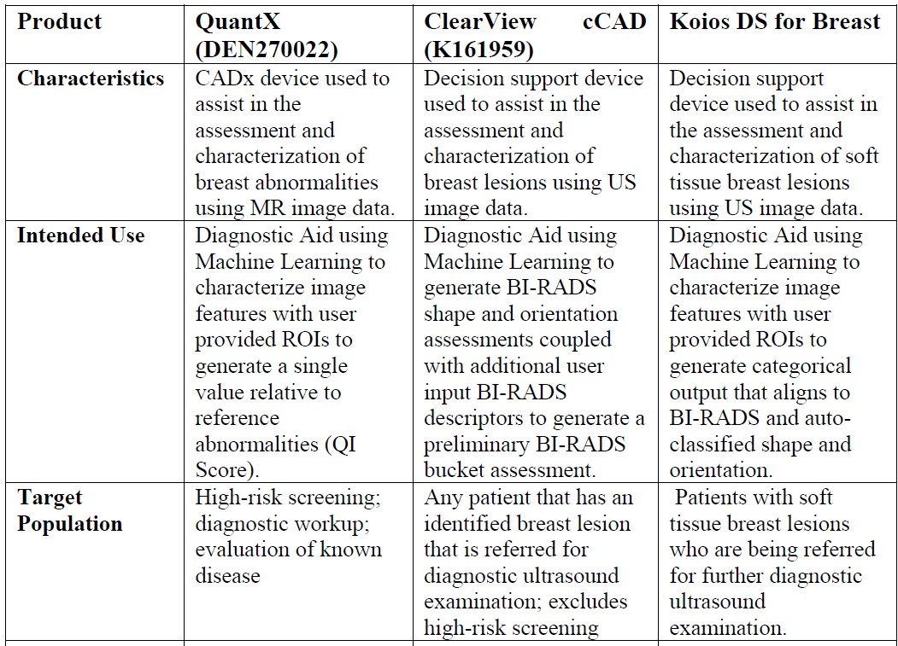

EchoMD Automated Ejection Fraction Software

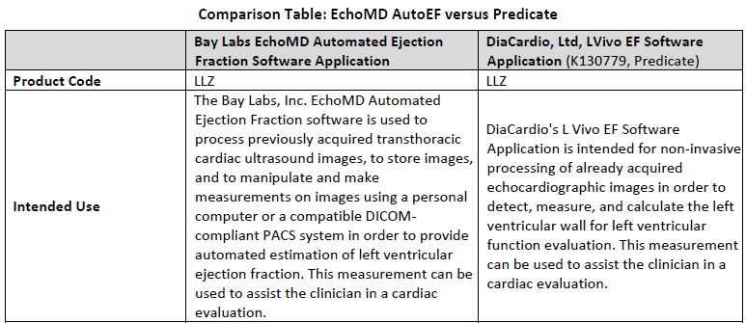

## 公司：MaxQ AI 平台：Accipio Insight

intracranial hemorrhage and stroke detection software （ICH颅内出血检测软件）

目的：提高对ICH的敏感度，为医生识别出需要提供治疗的患者并确定治疗优先级别

method:

1. Accipio Ix利用人工智能技术，在不对原本的工作流程产生影响的状态下，自动分析患者的非造影头部CT图像，更改原始序列或存储用户的受保护健康信息（PHI）
2. 集成到Philips CT scanner

## 数坤冠脉AI产品

冠脉CT造影图像血管狭窄分析软件

识别动静脉纠缠，进行运动伪影矫正，重建出清晰、准确的冠脉图像

敏感性和准确性：AI狭窄诊断的敏感性及准确性达到了三甲医院高年资医生水平。

准确性：全流程30分钟变3分钟，效率提升70%以上。

结构化报告：AI自动生成结构化的临床报告，可读性高，实现同质化和标准化。

图像质控：支持众多品牌 CT数据，可兼容更低质控质量的影像，普适性强

进入国家药品监督管理局（NMPA）三类证创新通道

一类是决策者

检查病人越多，收益就越多，即目标是加快检查时间

提高科研能力、学科地位

一类是使用者

精准诊断、疾病检出、良恶性鉴别、疗效评估等

三甲医院超负荷，基层医院能力有限

AI作用：

首先，快速检出病灶

其次，就是辅助科研

最后，报告标准化

优点：

加快流程：scan to report

由于疲劳产生的一致性：上午精力充沛的时候，写报告效率非常高，错误率也低，过了两个小时以后，精力会快速下降，尤其到下午，错误率和漏诊率会大幅升高

AI+医生 > 医生： 提升Jr. -> Sr.

报告标准化有助于科研

优先应用场景：

CT/MRI扫描脑部

CT心脏

CT肺

## 西门子医疗提出智慧诊断链条：

真正被临床接受、被NMPA认可、具有稳定的临床表现的应用产品很少？

第1个， AI的优势在于对明确逻辑或者是特定规则下进行学习和预测。而对于疾病诊断来说，很多诊断指南还在更新和完善的过程中，很多所谓的临床金标准的可信度也没有达到百分之百

第2个，医学影像仅是医学工作链条中的一个点，应从整体角度提高工作效率。

第3个，决定AI算法准确性的核心在源头：数据的采集是否规范、数据的标准是否统一、数据的质量是不是满足要求。

基于CT的操作指南以及诊断指南

1. 患者摆位和扫描范围

CT扫描指南有明确规定，扫描技师需要通过学习和训练来掌握这些细节。然而即便如此，摆位的偏差、扫描位置偏移，依然是存在的。技师间操作个体的差异是在所难免，也是无法消除的。解决方法：用AI解决人为区域选择误差

以CT扫描前的患者位置选择为例，西门子医疗研发了Alpha自动解剖结构识别技术，自动标记扫描区域，消除人为操作可能产生的误差，准确性达到99%；

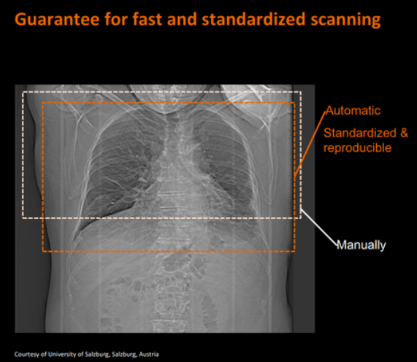 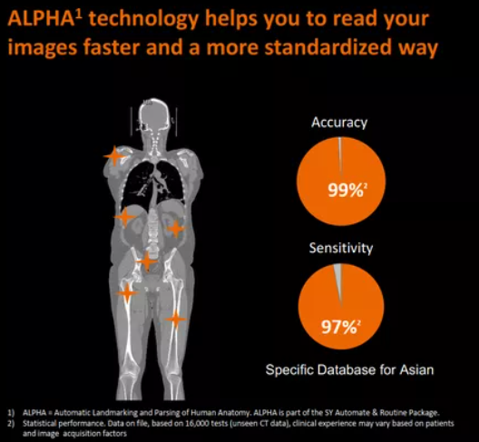

1. 扫描参数的设定

CT扫描参数的设置绝对要高于一台高品质单反相机的设置，如技师需要针对不同体型的人群，调节相关参数来获得稳定的图像质量，以及造影剂的相应增强水平。

利用AI自动推荐扫描参数，如自动管电流和电压调节技术可以根据患者体型和扫描部位，辅助技师选择最佳的扫描参数条件。

1. 图像重建

构建4种模型共同优化质量：系统模型、解剖结构感知模型、原始数据与统计模型以及噪声模型

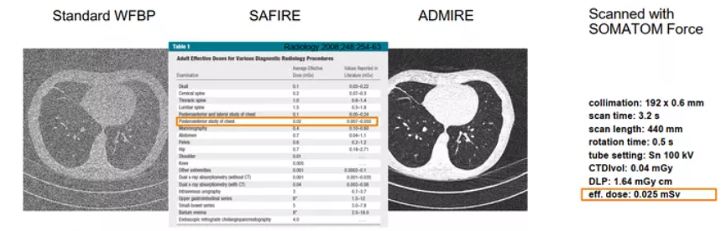

1. PACS viewing and diagnosis

心脏评估：钙化积分，心脏分割，冠脉束提取，评估患者冠脉狭窄

若灌注扫描,评估心功能,心肌缺血评估，

血流储备分数：传统方法，有创检查

基于CT图像的血流储备分数的一个评估的模型：通过对动脉束的建模，包括利用到这种仿真的、基于流体力学的血流压力的这些数据，我们可以训练出一个自动的来评估血流储备分数的一个计算机模型。

# 竞赛

眼底病识别

IDx-DR: screening for diabetic retinopathy

Airdoc的眼底病识别

肺结节

Arterys: aids in finding lesions and nodules within pulmonary CT scans and liver CT and MRI scan

肺结节竞赛

luna16.grand-challenge.org/results/

直径>3cm --肺肿块

直径<3cm --肺结节；

直么>2cm，且一半的比例是恶性的 --恶性结节

直径<1.5cm --肺小结节

直径<1cm 大部分是良性

肺结节和肺肿块都有良性恶性之分

斯坦福大学的皮肤癌识别

# Modality Imaging

## CT扫描和读片

截止到2019年底，全国CT装机量已经达到5600台，并且这个数字还在以每年16%的速度增长

目前在中国注册的影像相关诊断医生，包括技师和护士在内，总共只有15.8万人，相当于每百万人口中只有11个影像医生、这个群体的增长速度只有2.2%，远没有CT的增长速度快

* 1. 医生工作量的增加。据统计，一个医生每天要平均处理50个患者的影像数据，阅读25000张到50000张的医学图像
  2. 患者要等上好几天才能拿到自己的诊断报告。
  3. 工作量增加，即将医生工作时的处理时间缩短一半，那么诊断的错误率可能会提高16.6%

CT Reconstruction or denoising

<https://github.com/houguanqun/Low-Dose-CT-denoising>

[2012]Low-dose CT: technique, reading methods and image interpretation

Screening of high-risk populations with the use of low-dose computed tomography (LDCT) reduces lung cancer mortality.

[2018]Deep Learning Computed Tomography --Learning Projection-Domain Weights from Image Domain in Limited Angle Problems

Analytic formulate: Filter backed projection, iterative algorithm



P: 投影数据 f: 重建volume

Method:

FBP -> DL

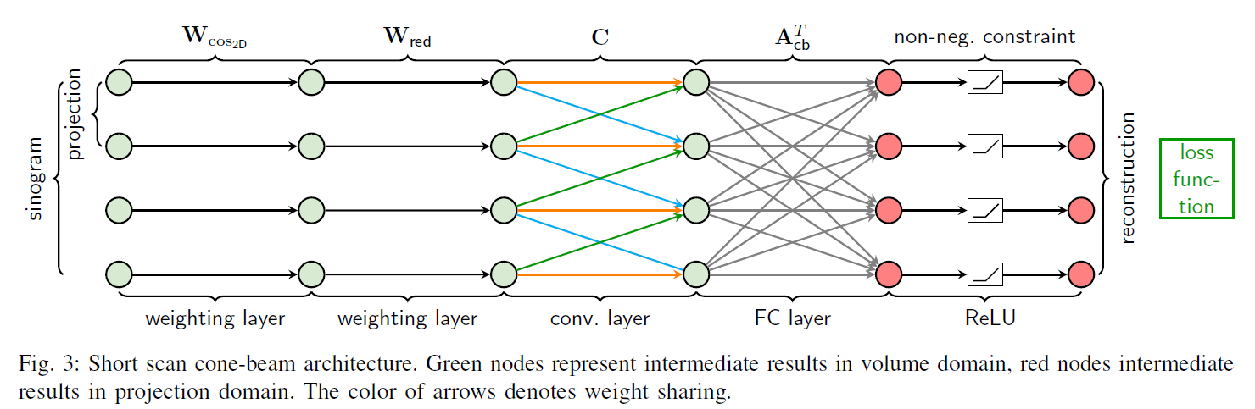

Data:

Ground truth: Volumes that were reconstructed from full dose projections

Input: projection data <- volumes

[2018]low dose CT image denoising using a generative adversarial network with Wasserstein Distance and Perceptual Loss

Background: reducing the radiation dose may lead to increased noise and artiacts. Hence,advanced image reconstruction from low-dose CT data is needed to improve the diagnostic performance, which is a challenging problem due to its ill-posed nature

* Denoising in projection domain
* Denoising in image domain
* Reconstruction method (e.g. Iterative algorithm, FBP)

[2018]SIPID: A deep learning framework for sinogram interpolation and image denoising in low-dose CT reconstruction.

本文结合正弦域和图像域一起进行处理。实际上就是在CT未成为图像之前的投影数据上先进行一个正弦图插值（用超分辨网络），而后投影数据开始转化为CT值，采用FBP。

# Ultrasound

the poor image quality such as poor spatial resolution and high noise

lack of standardization of imaging acquisition parameters, such as image resolution, timing of contrast agents use

# Implementation Tools

医疗扫描图像预处理

shartoo.github.io/medical_image_process/

# Organs

Breast

Screening mammography

[2019] International evaluation of an AI system for breast cancer screening

[2019] Deep Neural Networks Improve Radiologists’ Performance in Breast Cancer Screening

Liver

肝肿瘤

NIH(美国放射科协会)

www.auntminnie.com/index.aspx?sec=log&URL=http%3a%2f%2fwww.auntminnie.com%2findex.aspx%3fsec%3dsup%26sub%3daic%26pag%3ddis%26ItemID%3d118447

nihcc.app.box.com/v/ChestXray-NIHCC

HCC is surrounded by cirrhotic liver tissue (parenchyma) that in some cases has a very similar visual aspect, making HCC areas hard to recognize by the human eye.

the sensitivity of Bmode US for (hepatocellular carcinoma) HCC diagnosis is only 46%~63% . Therefore, US was only recommended as surveillance tool for liver lesion by guidelines.

[2020] Improving B-mode ultrasound diagnostic performance for focal liver lesions using deep learning: A multicentre study

Objective: to classify malignant from benign FLLs

Data: 13 hospitals, 2143 patients = 24,343 US images

Split: 11 hospitals training + 2 hospitals test

Result:

Input: US images + 7 US features + 7 clinical factors

AUC 0.92, superior to 15-year ragiologists (sen 86% vs 76%, spe 85% vs 77%)

Comparable to contrast enhanced CT, inferior to contrast enhanced MRI

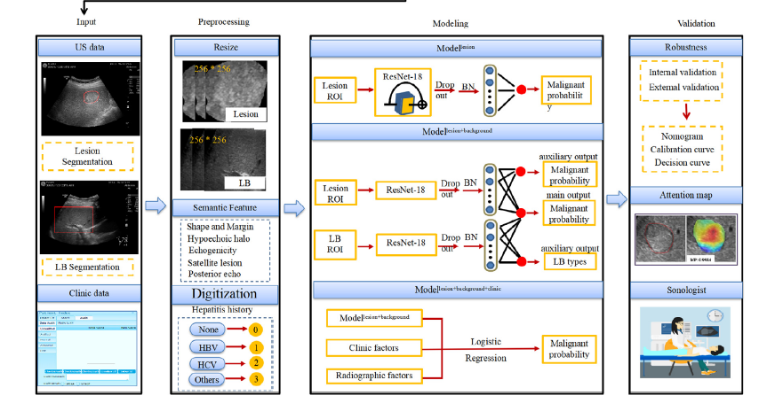

前沿

DDH: developmental dysplasia of the hip （诊断婴儿）发育性髋关节发育不良

婴儿6 个月内， 髋关节大部分还由软骨构成， 超声图像可以清晰显示髋关节的骨和软骨、盂唇的形态、股骨头的大小和位置以及关节囊软组织， 并在髋关节内收与外展时动态显示头与臼位置关系的变化。出生后的前6 个月， 软骨性髋关节不能被X 线识别， 因此超声成为婴儿DDH 诊断的首选影像学方法

在德国等欧洲地区，广泛采用超声对新生儿进行DDH 筛查， 而北美和英国爱尔兰等地区学者则主张对出生6 周以上的高危婴儿， 进行针对性体检并辅以超声检查［13 ］

髋关节超声测量内容包括： 中立位冠状切面图测量α 角、股骨头长径、宽径和股骨头覆盖率， 中立位外侧横切图测量耻头距、坐头距，屈髋位后外侧横切图测量头耻距

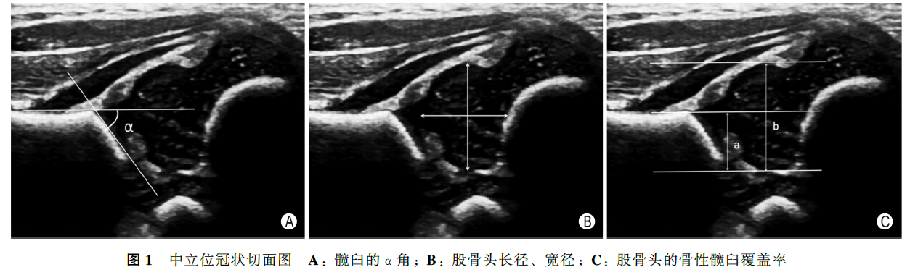

[2018]健康婴儿髋关节超声测量分析的多中心研究